**Using UNIX Basic Commands**

**Name : Samruddhi Rupesh Shivarkar**

**Emp Id: 26210117**

1. To display the current working directory, the command is:

pwd

The output is as follows. /home/trg1 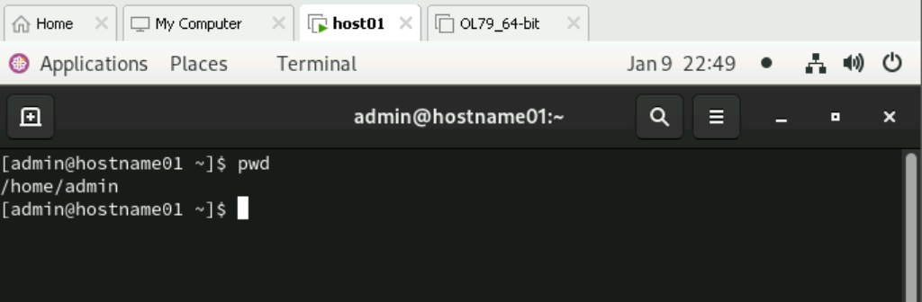

2. Display the path to and name of your HOME directory.

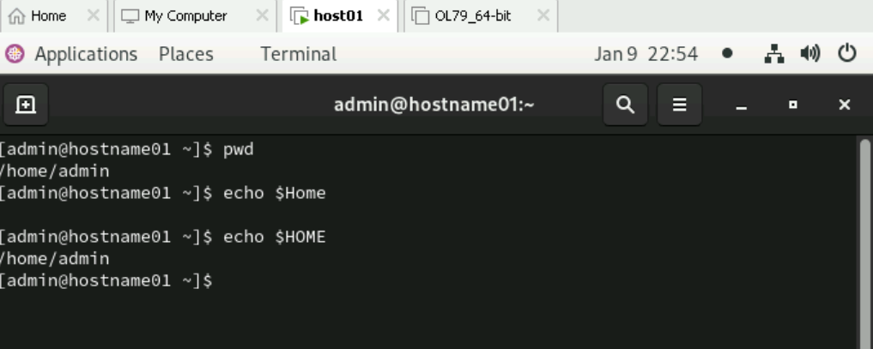

3. Display the login name using which you have logged into the system

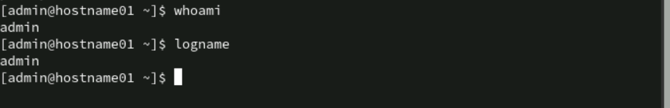

4. Display the hidden files of your current directory.

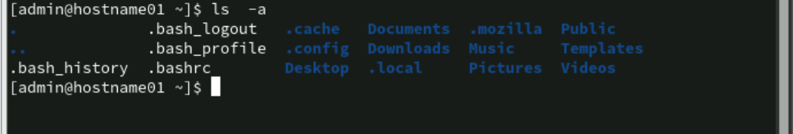

5. List the names of all the files in your home directory.

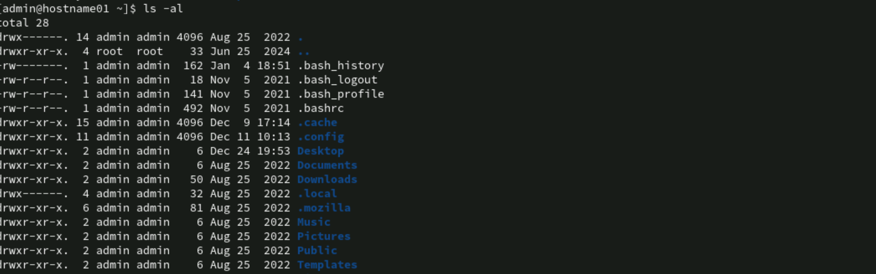

6. Using the long listing format to display the files in your directory.

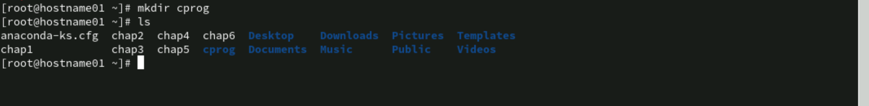

7. List the files beginning with chap followed by any number or any lower case

alphabet. (Example , it should display all files whose names are like chap1, chap2,

chap3 ……., chapa,ahapb,chapc,……..)

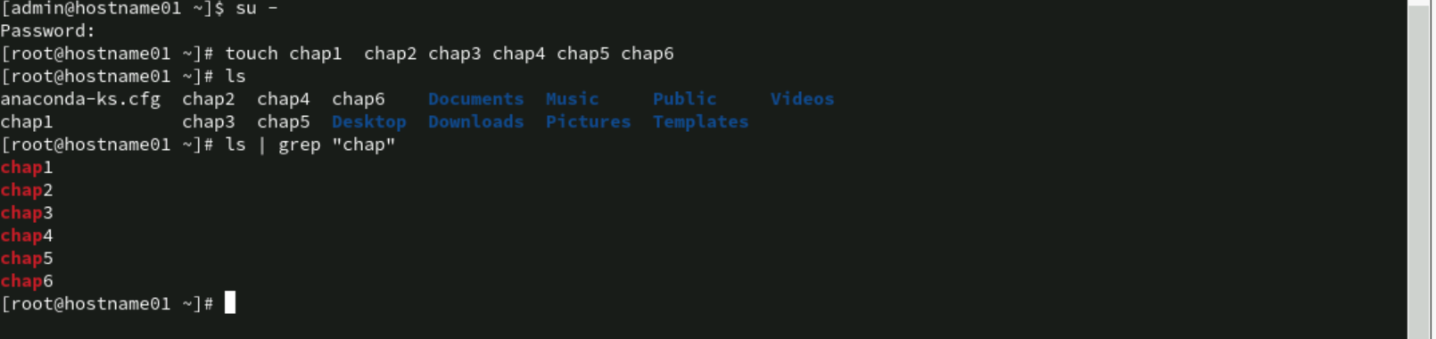

8. Give appropriate command to create a directory called C_prog under your home

directory. (Note: Check the directory using ls )



9. Create the following directories under your home directory. (Note: Check using ls )

newdir

newdirectory



10. List the names of all the files, including the contents of the sub directories under

your home directory.

11. Remove the directory called newdirectory from your working directory.



12. Create a directory called temp under your home directory.



13. Remove the directory called newdir under your home directory and verify the above with the help of the directory listing command.



14. Create another directory directorynew under the temp directory.



15. Change the directory to your home directory.



16. From your home directory, change the directory to directorynew using relative and

absolute path.

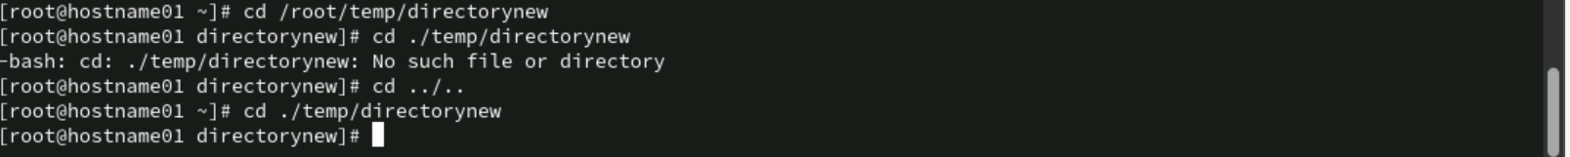

17. Remove the directory called c_prog, which is in your home directory.

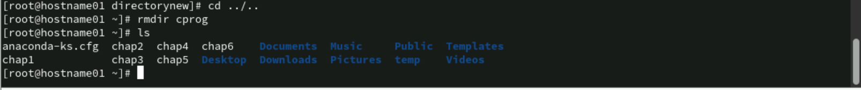

18. Change to the directory /etc and display the files present in it.

19. List the names of all the files that begin with a dot in the /usr/bin directory.

20. Create a file first.unix with the following contents.

Hi! Good Morning everybody.

Welcome to the First exercise on UNIX.

Hope you enjoy doing the assignments. 

21. Copy the file first.unix in your home directory to first.unics.

(Note: checked using ls, first.unix file also should exist along with first.unics)

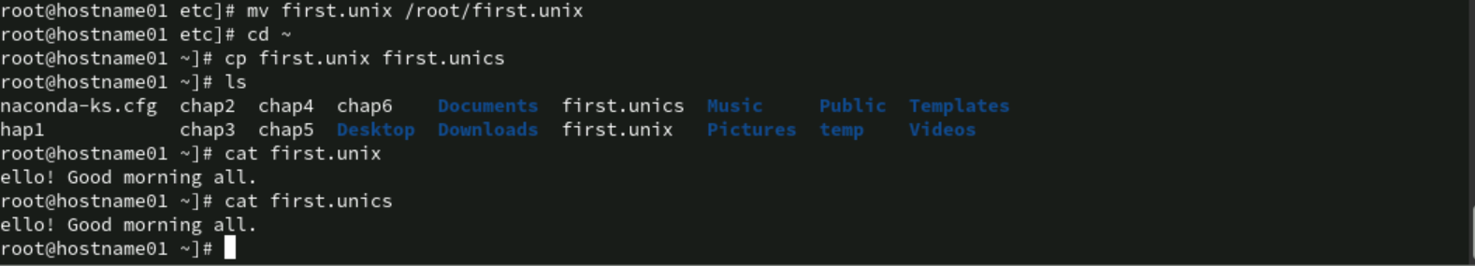

22. List the contents of first.unix and first.unics with a single command.



23. Create a new directory under the temp directory.

24. From your home directory, copy all the files to the directory created under the temp sub directory.

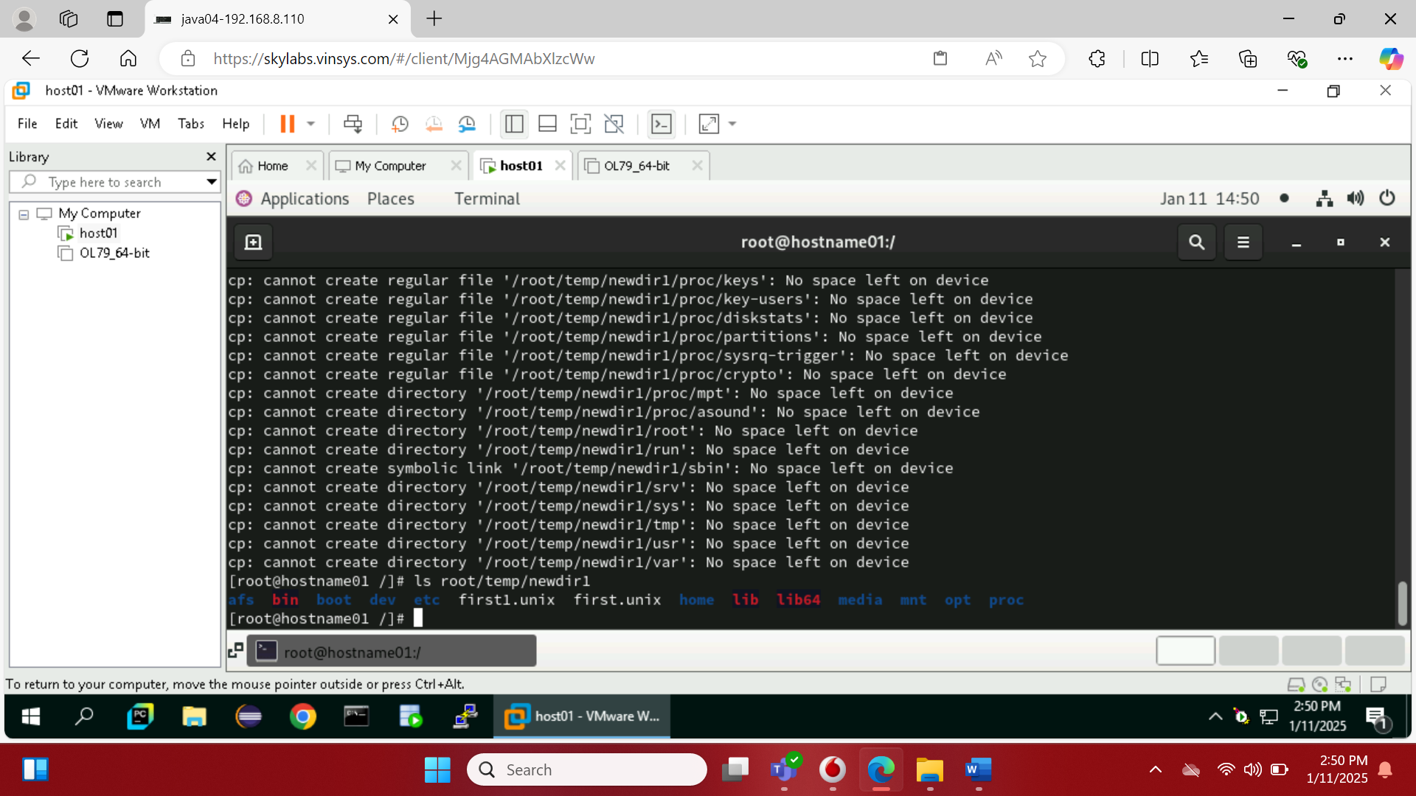

25. Move the file first.unix to the directory temp as second.unix

26. Remove the file called first.unics from the home directory.

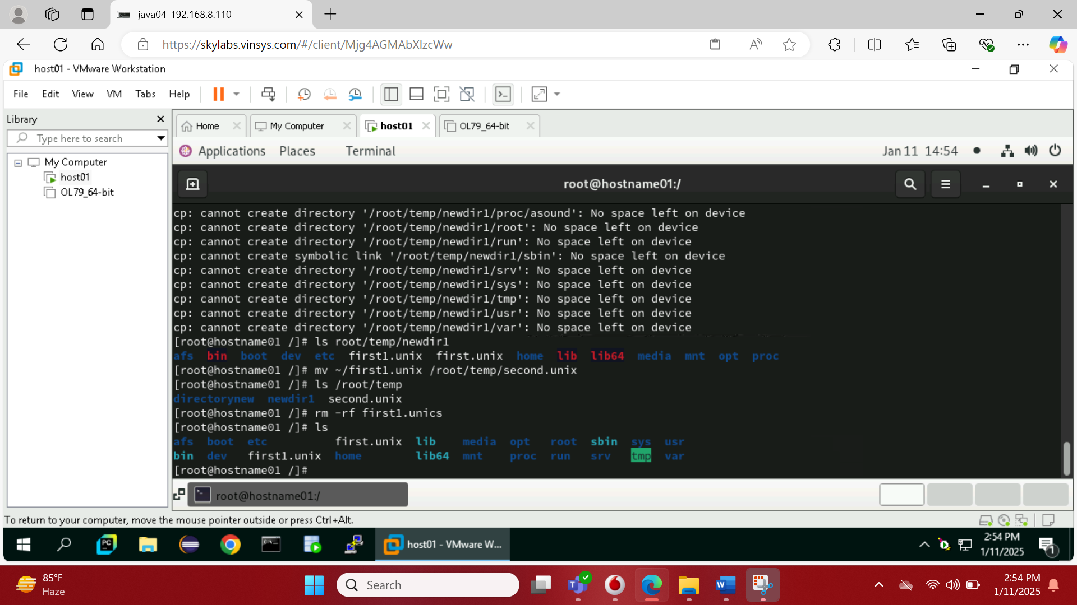

27. Change your directory to temp and issue the command rm *. What do you observe?

28. Move all files whose names end with a, c and o to the HOME directory.

29. Copy all files that end with a ‘UNIX’ to the temp directory.

30. Issuing a single command, remove all the files from the directory temp and the

directory itself.

31. Try commands cp and mv with invalid number of arguments and note the results.

32. Use the cat command to create a file friends, with the following data:

Madhu 6966456 09/07/68

Jamil 2345215 08/09/67

Ajay 5546785 01/04/66

Mano 7820022 09/07/68

David 8281292 09/09/60

Simmi 7864563 12/12/70

Navin 2224311 30/05/68

The fields should be separated by a tab.

33. Display contents of the file friends.

34. Copy contents of friends to newfriend without using the cp command.



35. Display contents of the file friends and newfriends in a single command.

36. Find all users currently working on the system and store the output in a file named

as users.

37. Append contents of friends file to the file, users.



38. Display current system date and time and record your observations. How is the

time displayed?

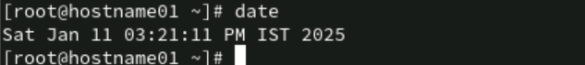

39. Display calendar for the month and year of your birth.

40. Try following commands and record your observations.

date “+ %”

date “+%m”

date “+%D”

date “+%/%Training Activity”

date “+%Training Activity”

date “+%r”

Using Pipes and Filters:

1: Redirect the content of the help document ls, into a file called as lsdoc.

2: Display the content of the lsdoc page wise.

3: Create a file data.txt using input redirection. 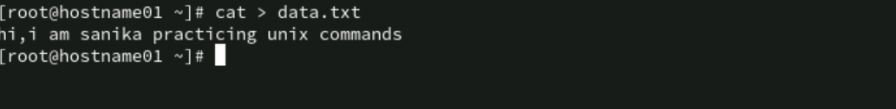

4: Display data.txt.

5: Remove the file data.txt.

6: Use error redirection to display data.txt, if any error stores it in errorlog.txt

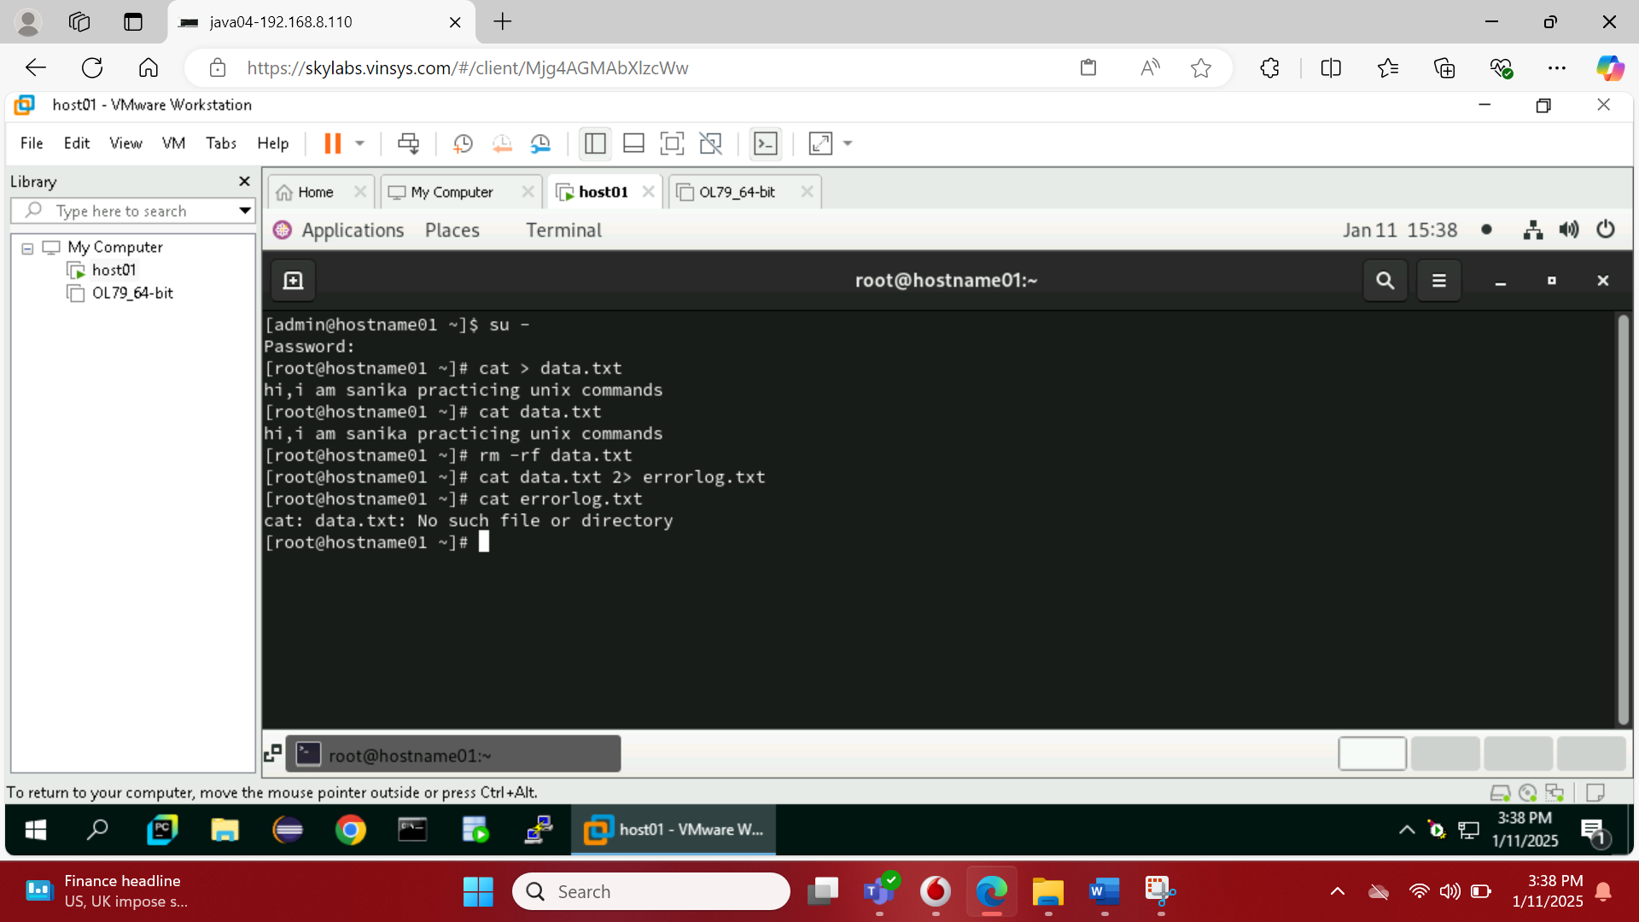

7: Display errorlog file.